PASTORAL PROFILE

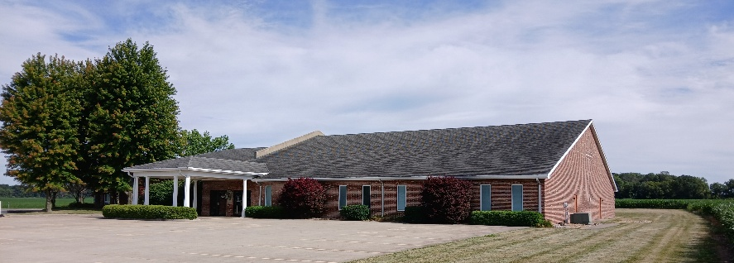
East Harrison Street Church of God needs a pastor with strong interpersonal skills who is able to cast vision and can lead the church into the future. This profile seeks to address the issues revealed in our 2024 assessment process.

PERSONAL / PREPARATION
- Age Range – 35-55 preferred but maturity and self-awareness are vital
- Marital Status – prefer married
- Bachelor’s degree completed preferably
- Aligned with the theology of the CGGC (https://cggc.org/about-us/who-we-are)
- Credentialed with the CGGC (Findlay, OH) or willing to complete the process through our Midwest Region of the CGGC
- 5+ years of ministry experience
- Demonstrated long-term stability in one location

STYLE OF MINISTRY
- A proven visionary leader with a record of accomplishing Spirit-led goals
- Personable with an ability to connect with multiple generations
- Servant leader who sets an example by engaging in the community
- Passionate and effective communicator of God’s word
- Encouraging and mobilizing others in gifts-based ministries

PASTORAL PRIORITIES (based on our assessment)
- Preaching/teaching with life application
- Personal spiritual development (growing as a person)
- Developing leaders (growing others)
- Shepherding the church family through visits, communication, etc.

DESIRED STRENGTHS & SPIRITUAL GIFTS
- Strong and experienced biblical preacher
- Strong leadership skills
- Personable and able to connect with people
- Able to bring unity and vision

If interested, please send (1) a resume, (2) a cover letter; and (3) a media link to two of your sermon videos to: EHSPastoralSearch@gmail.com by April 30, 2025.

